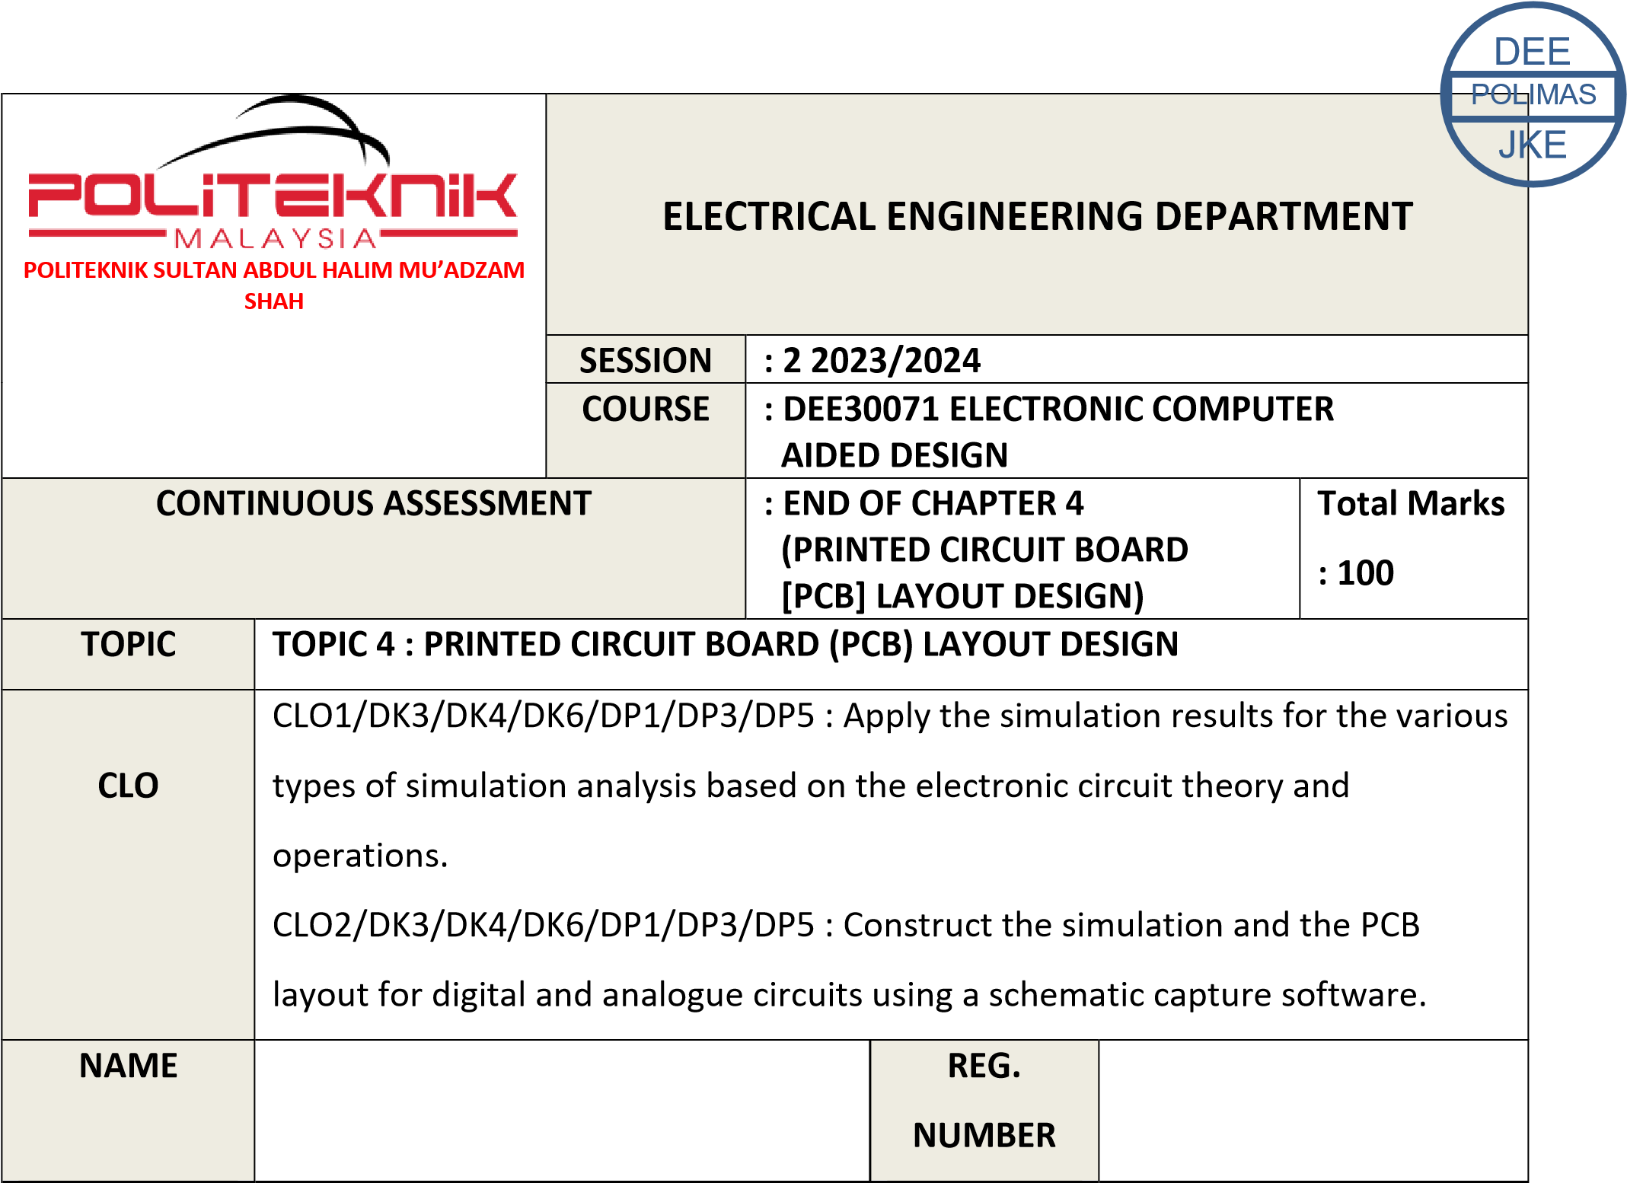

03DET22F1043

CHONG KHENG CHEN

|  |  |  |
| --- | --- | --- |
| CLO2 (P4, PLO5) | PSYCHOMOTOR ASSESMENT  (100 %) |  |
|  | TOTAL MARKS  (100%) |  |

**\*Refer to Rubric**

|  |  |
| --- | --- |
| **1** | **LEARNING OUTCOMES (LO):**    **1.** Construct the simulation and the PCB layout for digital and analogue circuits using a schematic capture software. (CLO2, P4, PLO5) |
| **2** | **OBJECTIVE**    Student should be able to:   1. Transfer components from schematic editor to PCB editor. 2. Organize components manually and automatically. iii. Show connection of power plane and ground plane. iv. Edit component footprints and pad size. |
| **3** | **THEORY**    A **printed circuit board** (**PCB**) mechanically supports and electrically connects [electronic components](https://en.m.wikipedia.org/wiki/Electronic_components) or [electrical](https://en.m.wikipedia.org/wiki/Electrical) components using [conductive](https://en.m.wikipedia.org/wiki/Electrical_conductor) tracks, pads and other features [etched](https://en.m.wikipedia.org/wiki/Industrial_etching) from one or more sheet layers of copper [laminated](https://en.m.wikipedia.org/wiki/Laminated) onto and/or between sheet layers of a [non-conductive](https://en.m.wikipedia.org/wiki/Insulator_(electricity)) substrate. Components are generally [soldered](https://en.m.wikipedia.org/wiki/Soldering) onto the PCB to both electrically connect and mechanically fasten them to it.  Printed circuit boards are used in all but the simplest electronic products. They are also used in some electrical products, such as passive switch boxes.  Alternatives to PCBs include [wire wrap](https://en.m.wikipedia.org/wiki/Wire_wrap) and [point-to-point construction,](https://en.m.wikipedia.org/wiki/Point-to-point_construction) both once popular but now rarely used. PCBs require additional design effort to lay out the circuit, but manufacturing and assembly can be automated. Specialized CAD software is available to do much of the work of layout. Mass-producing circuits with PCBs is cheaper and faster than with other wiring methods, as components are mounted and wired in one operation. Large numbers of PCBs can be fabricated at the same time, and the layout only has to be done once. PCBs can also be made manually in small quantities, with reduced benefits.  PCBs can be single-sided (one copper layer), double-sided (two copper layers on both sides of one substrate layer), or multi-layer (outer and inner layers of copper, alternating with layers of substrate). Multi-layer PCBs allow for much higher component density, because circuit traces on the inner layers would otherwise take up surface space between components. The rise in popularity of multilayer PCBs with more than two, and especially with more than four, copper planes was concurrent |

|  |  |
| --- | --- |
|  | with the adoption of [surface mount technology.](https://en.m.wikipedia.org/wiki/Surface_mount_technology) However, multilayer PCBs make repair, analysis, and field modification of circuits much more difficult and usually impractical. |
| **4** | **EQUIPMENT / TOOLS**     1. PC workstation 2. Related software |
| **5** | **PROCEDURE**       1. Construct the circuit in Figure 5a. 2. Perform Physical Part List View. 3. Copy schematic in question (a) to PCB layout design. 4. Display PCB layout for both Top and Bottom View. |

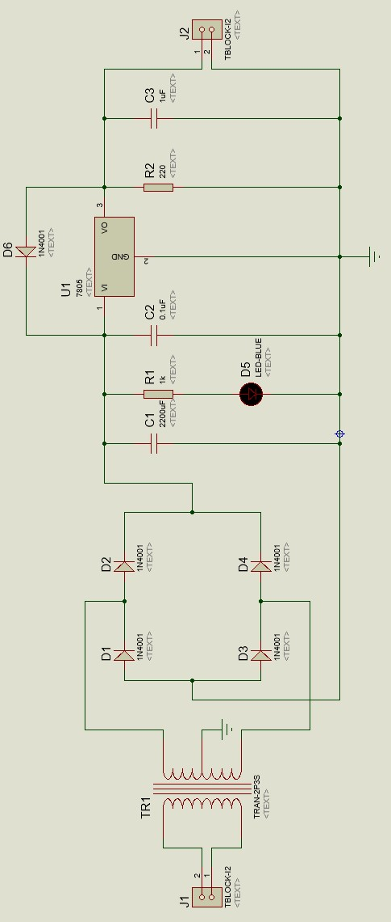

Figure 5

a

|  |  |
| --- | --- |
|  | **RESULT**       1. CONSTRUCT THE CIRCUIT           **B** PCB layout |

|  |  |  |  |  |  |  |
| --- | --- | --- | --- | --- | --- | --- |
| **PRACTICAL END OF CHAPTER 4** | | | | | | |
| Course Learning  Outcomes(CLO)/  Learning Domain Cluster (CLS) | Circuit | Skills / Aspects | Very Poor | Satisfactory | Very Good | Marks |
| 1 | 2 | 3 |
| CLO 1 : Apply the simulation results for the various types of simulation analysis based on the electronic circuit theory and operations.    CLO 2: Construct the simulation and the PCB layout for digital and analogue circuits using a schematic capture software.    CLS 1:  Knowledge &  Understanding    CLS3a :  Practical skill | 5a | **Construct circuit:** Student able toconstruct the circuit same as given. | Able to construct the circuit with assistance. | Good to construct the circuit moderately with little assistance. | Excellent to construct the circuit effectively. | /3 |
| **Physical part list view:** Student able to show physical part list view. | Able to show physical part list view with assistance. | Good to show  physical part list view with little assistance. | Excellent to show physical part list view effectively. | /3 |
| **PCB layout design :** Student able to transfer the circuit to PCB Layout design. | Able to transfer the circuit to PCB Layout design with assistance. | Good transfer the circuit to PCB Layout design with little assistance. | Excellent transfer the circuit to PCB Layout design effectively. | /3 |
| **Draw PCB Layout:**  Student able to link the footprint | Able to link the footprint with assistance. | Good to link the footprint with little assistance. | Excellent to link the footprint effectively. | /3 |
| **Draw PCB Layout:** Student able to setting the grid | Able to setting the grid with assistance. | Good to setting the grid with little assistance. | Excellent to setting the grid effectively. | /3 |
| **Draw PCB Layout:** Student able to setting the componens tools | Able to setting the componens tools with assistance. | Good to setting tthe  componens tools  with little assistance. | Excellent to the componens tools effectively. | /3 |
| **Draw PCB Layout:** Student able to setting the obstacle layers's properties | Able to setting the obstacle layers's properties with assistance. | Good to setting tthe obstacle layers's properties with little assistance. | Excellent to the obstacle layers's properties effectively. | /3 |
| **Draw PCB Layout:** Student able to setting the layers of routings | Able to setting the layers of routings with assistance. | Good to settingthe  layers of routings with little assistance. | Excellent to the layers of routings effectively. | /3 |
| **Draw PCB Layout:** Student able to routing PCB automatically | Able to routing PCB automatically with assistance. | Good to routing PCB automatically  with little assistance. | Excellent to routing PCB automatically effectively. | /3 |
| **PROCESS OF**  **SINGLE LAYER PCB:** Student able to setting single layer PCB artwork . | Able to Student able to setting single layer PCB artwork with assistance. | Good to Student able to setting single layer PCB artwork with little assistance. | Excellent to Student able to setting single layer PCB artwork effectively. | /3 |
| **PROCESS OF**  **SINGLE LAYER PCB:** Student able to preview the top layer . | Able to Student able to preview the top layer with assistance. | Good to Student able to preview the top layer with little assistance. | Excellent to Student able to preview the top layer effectively. | /3 |
|  |  | **PROCESS OF**  **SINGLE LAYER PCB:** Student able to preview the bottom layer . | Able to Student able to preview the bottom layer with assistance. | Good to Student able to preview the bottom layer with little assistance. | Excellent to Student able to preview the bottom layer effectively. | /3 |
|  | | |  |  | TOTAL | /36 |

# PRACTICAL SKILLS PSYCHOMOTOR ASSESMENT - (100%)

|  |  |  |  |
| --- | --- | --- | --- |
| **NO.** | **STUDENT’S NAME** | **Total:** | **100%** |
|  |
|  |  | **(36 marks)** |  |
| **1** | CHONG KHENG CHEN | /36 | /100 |